- SOMNATH (192472386)
EXP1:
Student scores
Aim: To calculate the average score for each subject using NumPy and identify the subject with the highest average score.
Output:
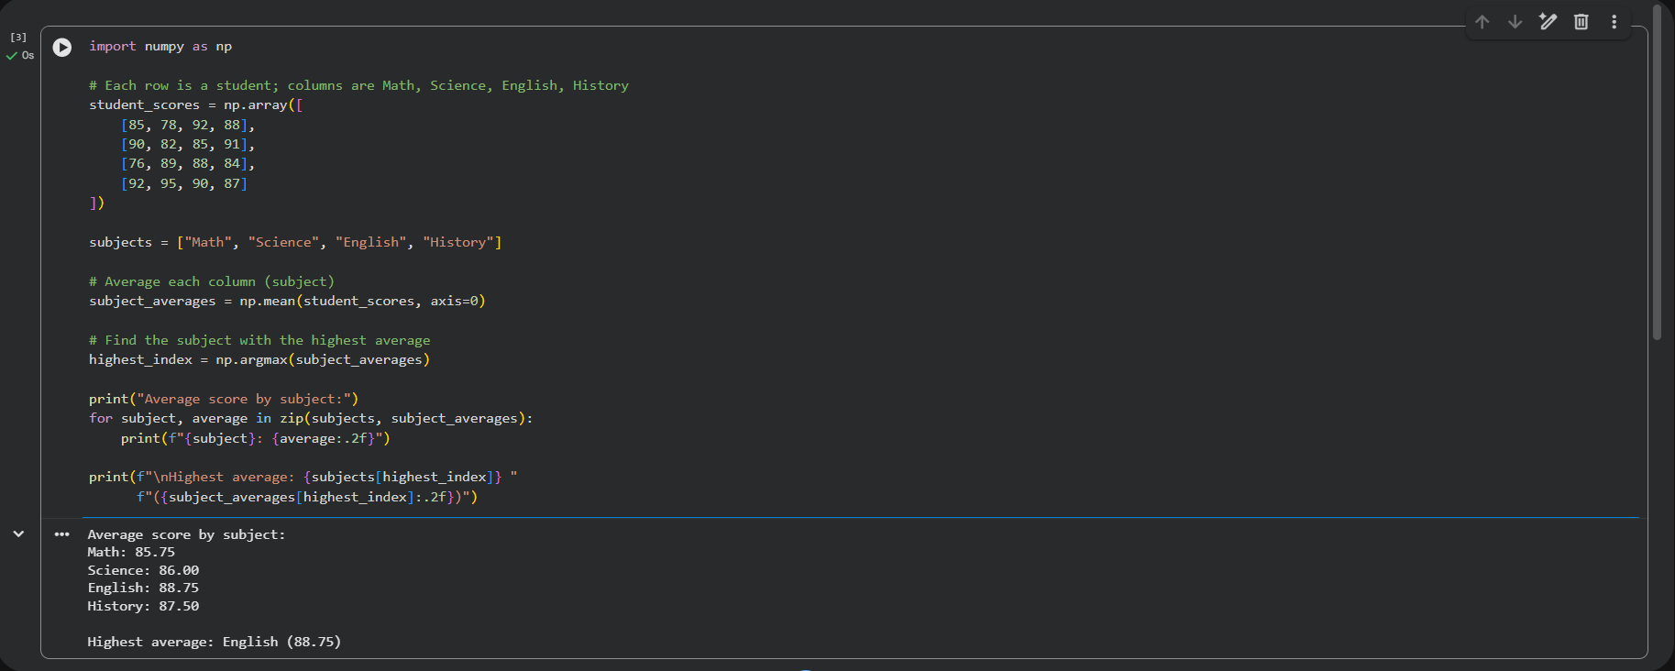
Result: The average scores were Math: 85.75, Science: 86.00, English: 88.75, and History: 87.50. English had the highest average score at 88.75.

EXP 2:
Average product price
Aim: To calculate the average price of all products sold using NumPy.
Output:
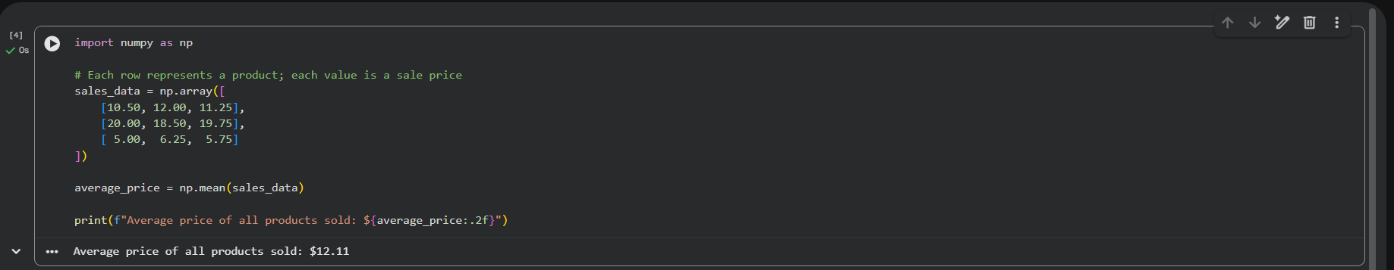
Result: The average price of the nine sample sales was $12.11.

EXP3:
Average house sale price
Aim: To find the average sale price of houses with more than four bedrooms using NumPy.
Output:
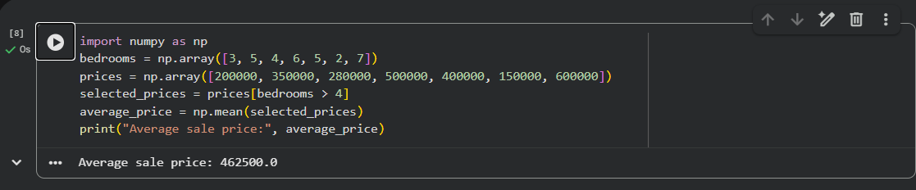
Result: The average sale price for the sample houses with more than four bedrooms was $462,500.

EXP4:
Quarterly sales
Aim: To calculate the total annual sales and the percentage increase from the first quarter to the fourth quarter.
Output:
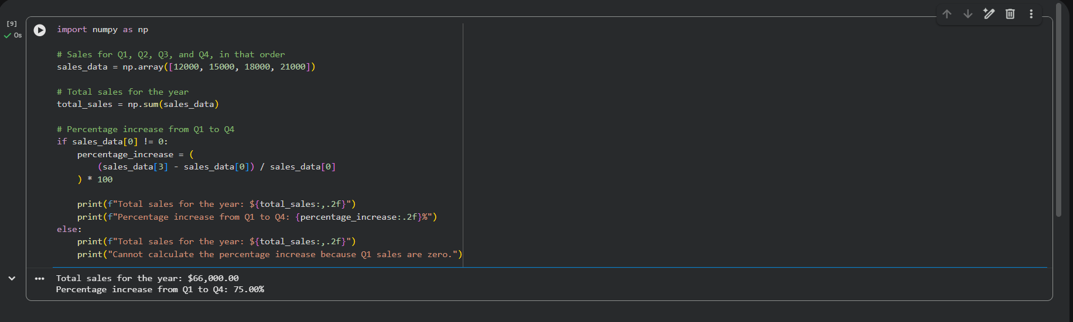
Result: Total sales were $66,000, and sales increased by 75% from Q1 to Q4.

EXP5:
Fuel efficiency
Aim: To calculate the average fuel efficiency of car models and the percentage improvement between two models.
Output:
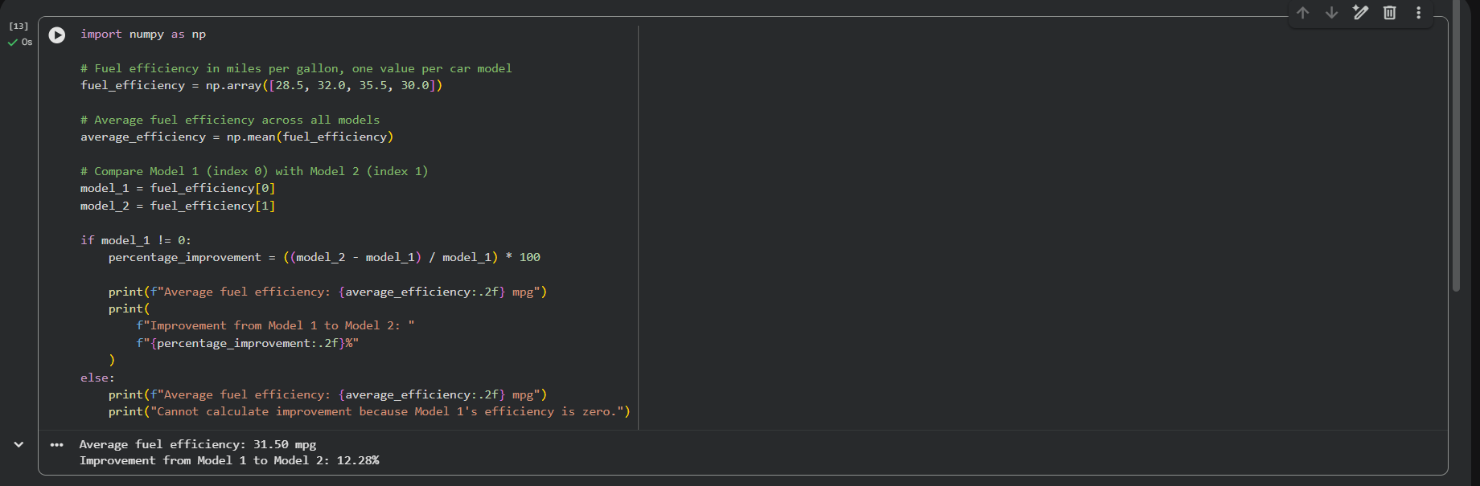
Result: The average fuel efficiency was 31.50 mpg. Model 2 showed a 12.28% improvement over Model 1.

EXP6:
Grocery purchase cost
Aim: To calculate a customer’s total purchase cost after applying a discount and tax.
Output:
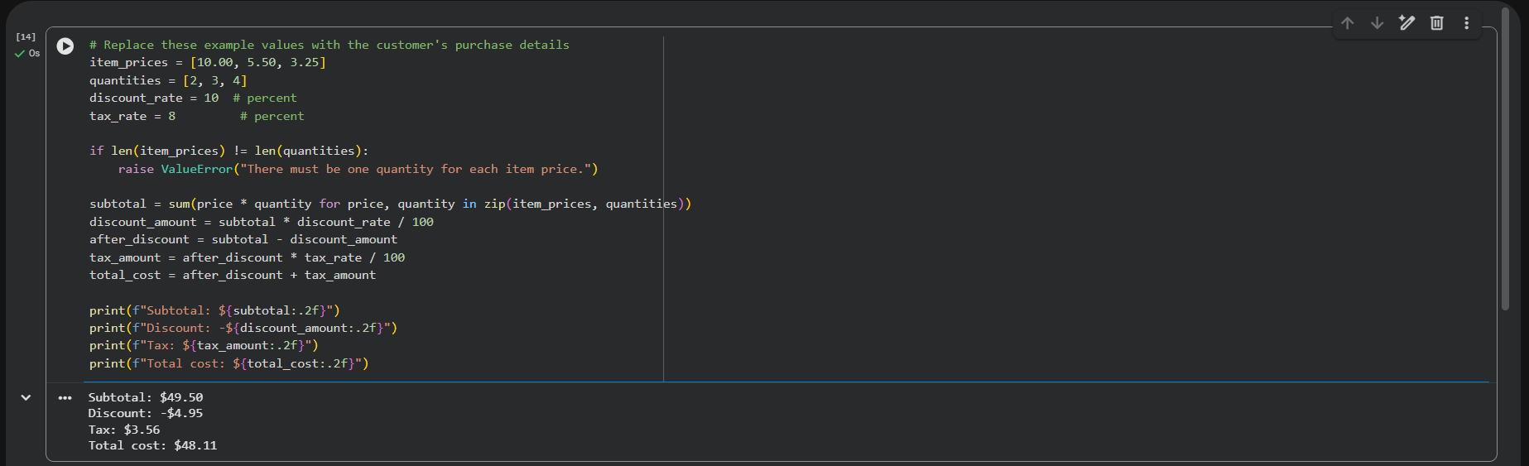
Result: The sample purchase had a subtotal of $49.50. After a 10% discount and 8% tax on the discounted amount, the total cost was $48.11.
EXP7:
Customer orders
Aim: To analyze order data using Pandas by counting orders per customer, calculating average quantity per product, and finding the earliest and latest order dates.
Output:
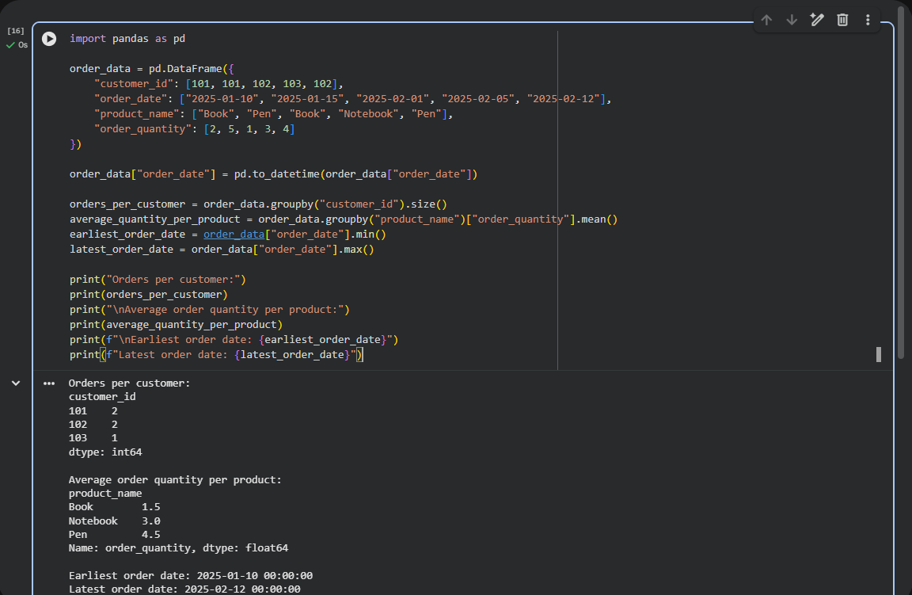
Result: Customers 101 and 102 each made 2 orders; customer 103 made 1. Average quantities were Book: 1.5, Notebook: 3.0, and Pen: 4.5. The earliest order date was January 10, 2025, and the latest was February 12, 2025.

EXP8:
Top-selling products
Aim: To identify the five products with the most sales during the past month using Pandas.
Output:
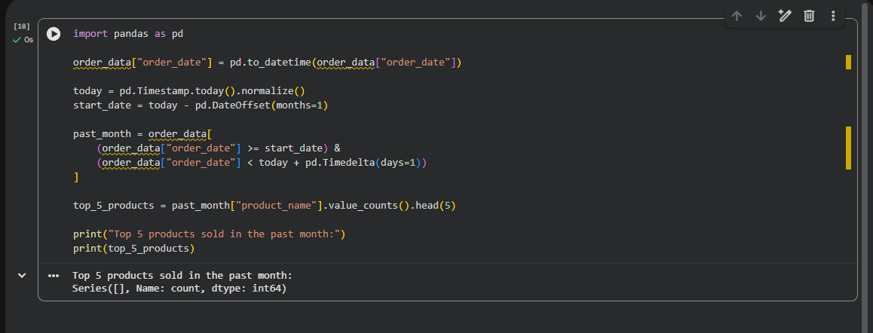
Result: The code ran, but the result was empty because no rows in the sample data matched the past-month date range. Using dates within the selected period will produce the top five products.

EXP9:
Property analysis
Aim: To use Pandas to find the average listing price by location, count properties with more than four bedrooms, and identify the property with the largest area.
Output:
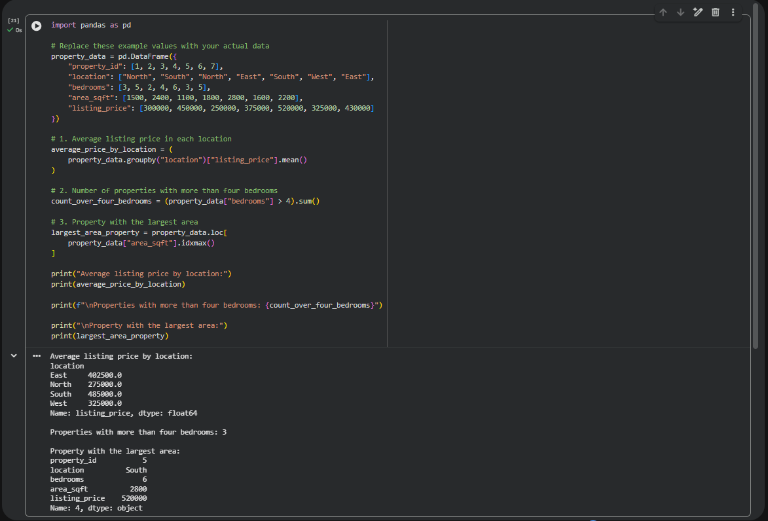
Result: Average listing prices were East: $402,500, North: $275,000, South: $485,000, and West: $325,000. There were 3 properties with more than four bedrooms. Property 5 had the largest area at 2,800 sq ft.

EXP10:
Monthly sales plots
Aim: To visualize monthly sales data using Matplotlib line and bar plots.
Output:
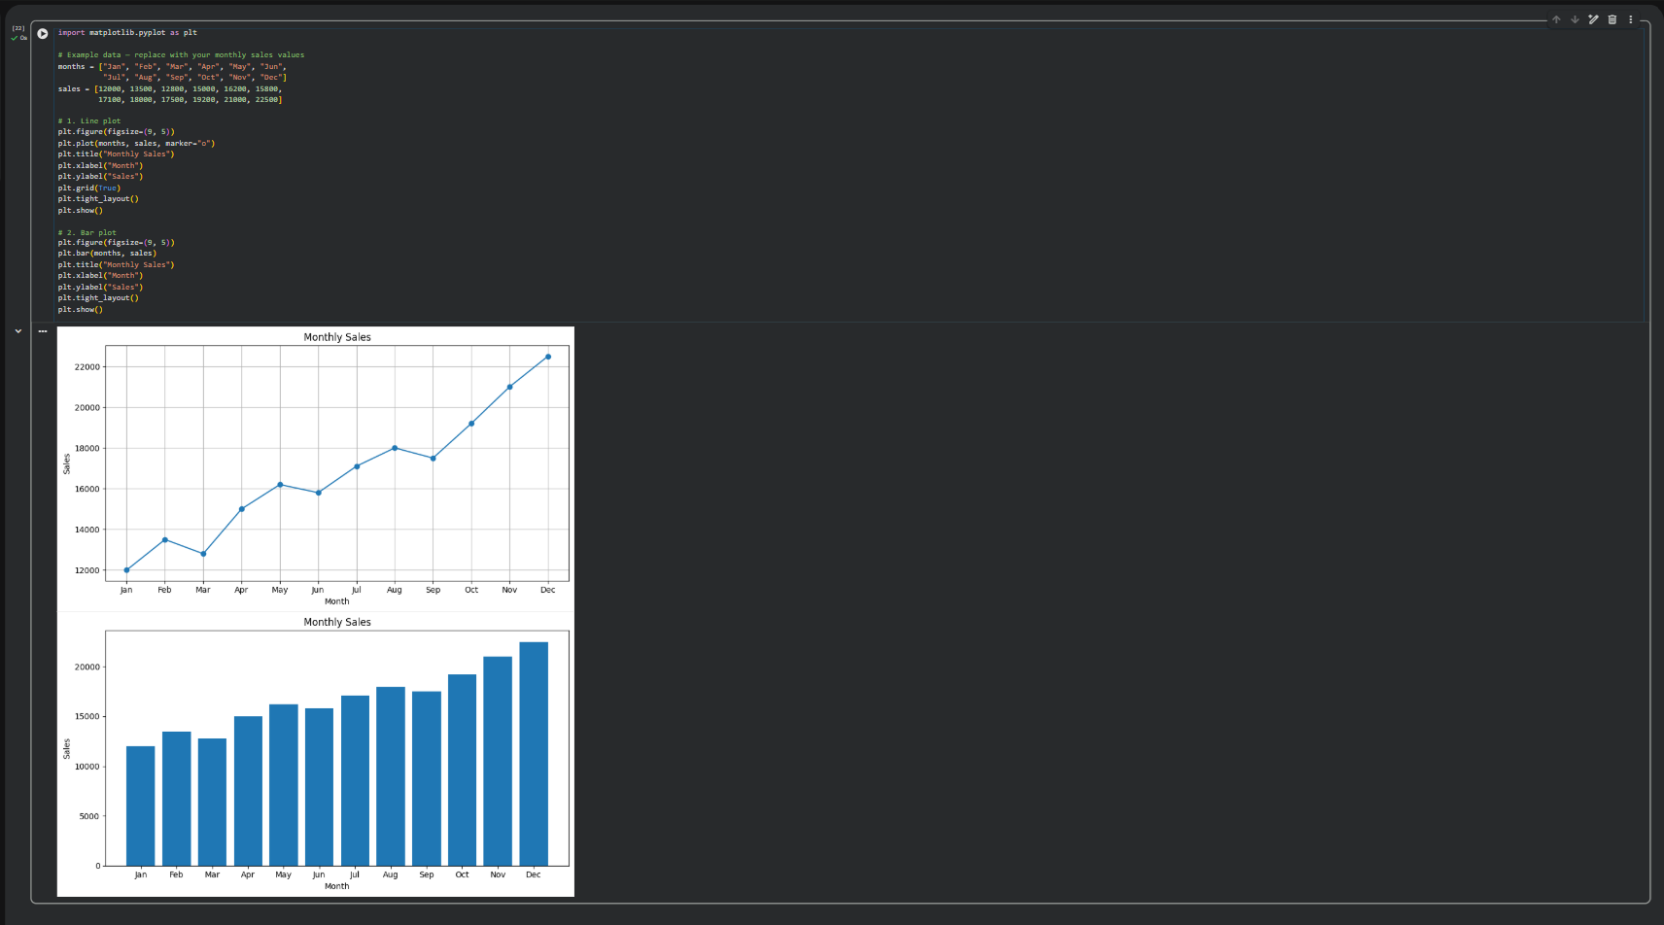
Result: The program successfully generated a line plot and a bar plot showing the sample monthly sales. Sales were generally higher toward the end of the year, with December showing the highest value.

